Project Development Phase
Performance Test

Date | 08/10/2026
Team ID | SWTID-2026-3272
Project Name | Implement Client Script and UI Policy (Incident)
Maximum Marks | 10 Marks

Model Performance Testing:
Project team shall fill the following information in model performance testing template.
S.No. | Parameter | Screenshot / Values
 | Data Rendered | Data source - Incident table [incident] in ServiceNow; the Incident form is rendered with the UI Policies and Client Scripts applied.  Fields rendered - Number, Caller, Category, Subcategory, Urgency, Impact, Priority, State, Assignment group, Assigned to, Short description, Description, Close code, Close notes.  Rendering behaviour - On form load the onLoad Client Script displays a guidance message; field behaviour (mandatory / read-only) is then driven by the UI Policies.  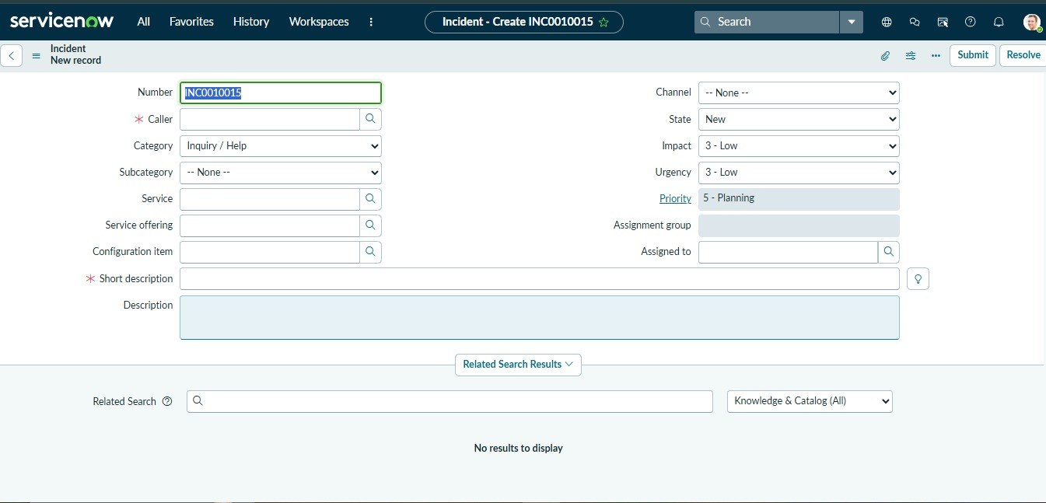
 | Data Preprocessing | Validation before save - onSubmit Client Script "Validate Short Description" checks that the short description has at least 10 characters and blocks Save with an error message if not.  Required data - UI Policy makes Assignment group and Description mandatory for High urgency incidents, so incomplete records are not saved.  Cleaning - No import or transformation was needed; data is entered directly on the form.  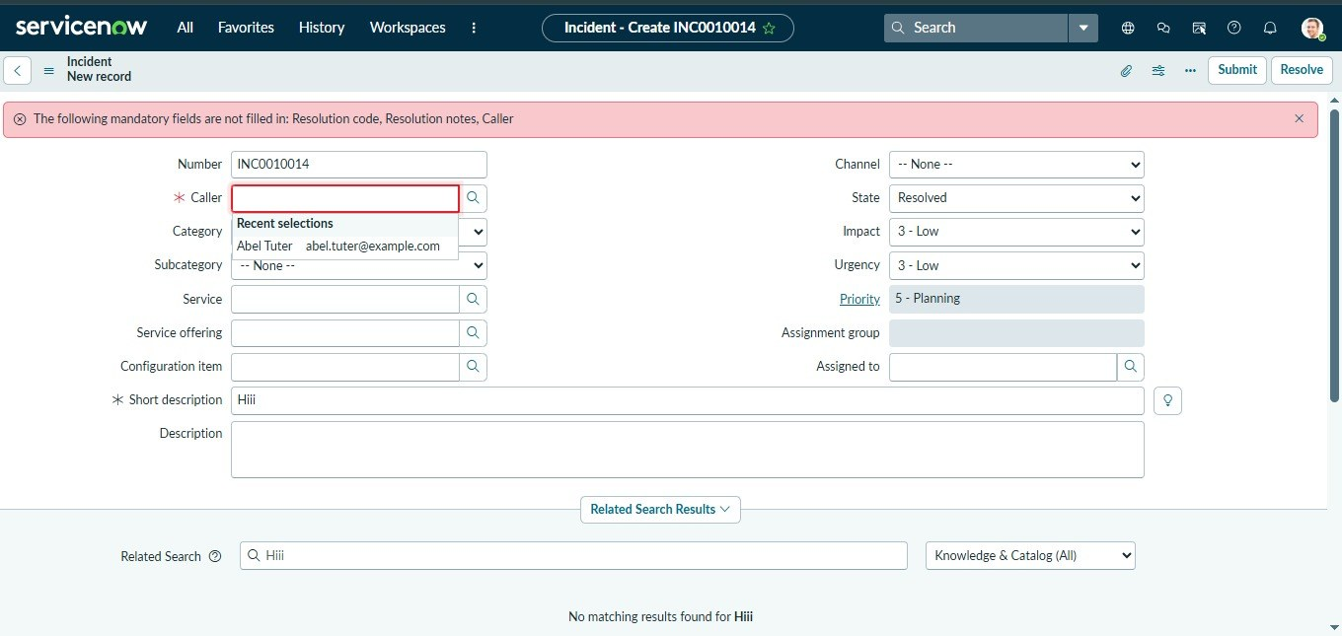
3. | Utilization of Filters | UI Policy conditions - Urgency is 1 - High (mandatory fields); State is Closed (read-only fields).  Client Script trigger - onChange on the Urgency field runs only when the new value is 1 - High.  List filter - Incident list filtered on Active = true and Urgency = 1 - High to pick the records used for testing.  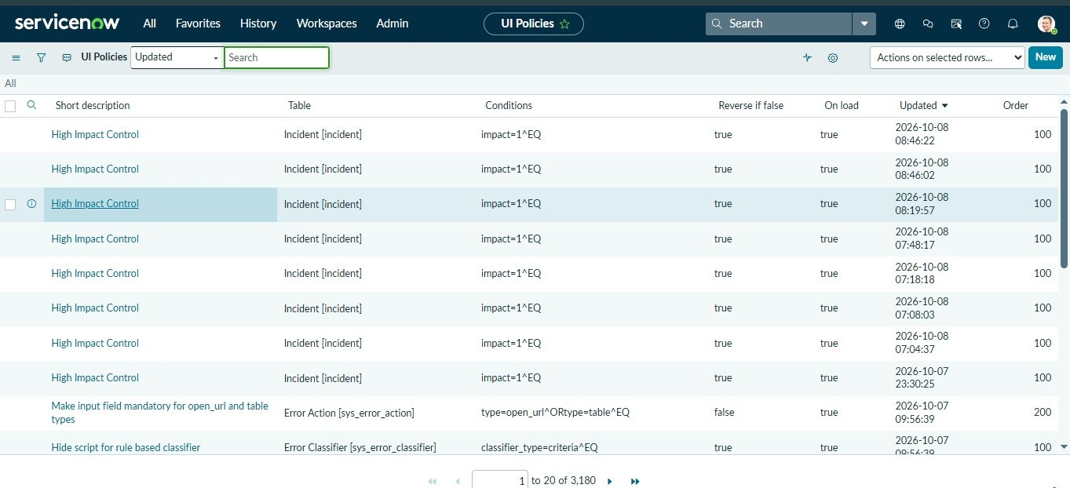
4. | Calculation fields Used | Priority - calculated field: Priority is derived from Impact and Urgency by the priority lookup, and is shown on the form when Urgency changes.  Length check - s.length < 10 in the onSubmit script, where s = g_form.getValue('short_description').  Reverse if false - UI Policy setting that returns Assignment group and Description to optional when Urgency is no longer 1 - High.  [Insert screenshot: Priority value changing with Impact / Urgency; UI Policy "Reverse if false" option]
5. | Dashboard design | No of Visualizations / Graphs - 0 (not applicable; this project is a form-level configuration with no dashboard).  Form design - Incident form with 2 UI Policies and 3 Client Scripts (onLoad, onChange, onSubmit).  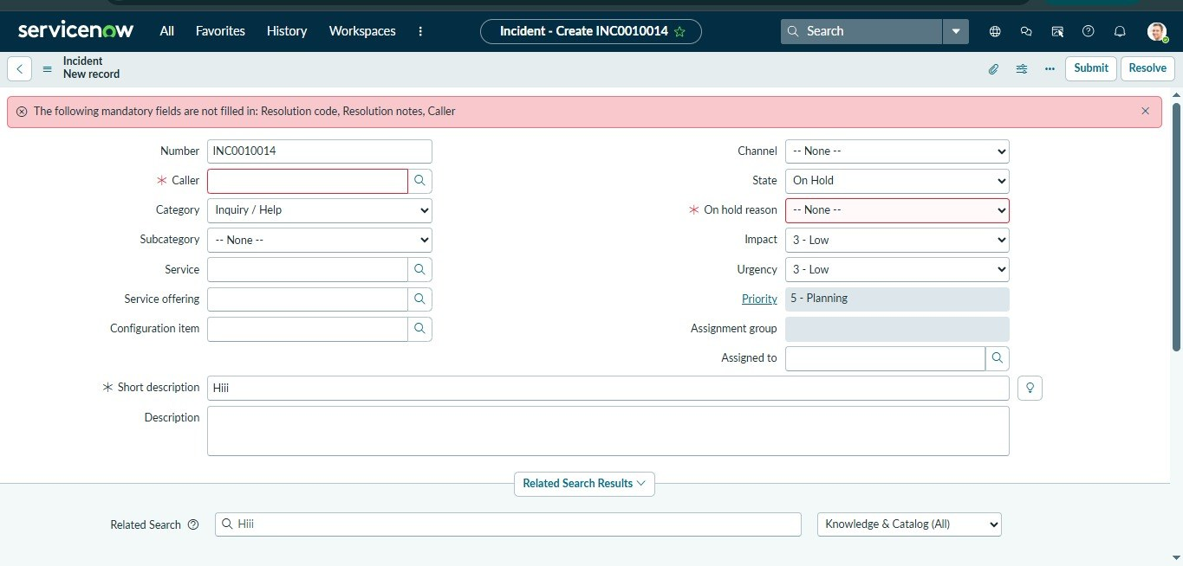
6. | Story Design | No of Visualizations / Graphs - 0 (not applicable).  Scenario flow - 1) Open a new incident and see the guidance message. 2) Set Urgency to 1 - High: alert shown, Assignment group and Description become mandatory. 3) Save with a short description under 10 characters: error shown, save blocked. 4) Correct the data and save. 5) Close the incident: Short description, Category and Caller become read-only.  [Insert screenshots: one for each step of the scenario flow]

